- List the seven data flow testing coverage criteria as outlined by Naik &Tripathy
- All-Defs (All Definitions Coverage): This criterion requires that every variable's definition be followed by a 'use' in the program C or P use; it doesn't matter; this ensures that variables are utilised after being defined, helping to catch uninitialised variables or definitions that are never used.
- All-Uses (All Uses Coverage): This criterion extends beyond All-Defs by requiring that every variable's use (both computational and predicate uses) be reached from every definition. It ensures that every way a variable can be used after being defined is tested, covering more potential paths through the program.
- All-DU-Paths (All Definition-Use Paths Coverage): This is one of the most rigorous criteria (aside from all paths), requiring that every possible path from a definition of a variable to its use is executed at least once. Some definitions to a single use may be joined by multiple du-paths, we need to account for this.
- All-C-Uses (All Computational Uses Coverage): This criterion ensures that every computational use of a variable (where the variable is used in a calculation) is tested from every definition. It helps identify errors in the logic that processes data.
- All-P-Uses (All Predicate Uses Coverage): Unlike All-C-Uses, this criterion ensures that every predicate use of a variable (where the variable is part of a condition) is tested from every definition. Checks more logic than computation.
- All-C-Uses/Some-P-Uses: This combines elements of both computational and predicate uses. It requires comprehensive testing of all computational uses and at least some testing of predicate uses, if a variable does not have a c-use, providing a balanced approach that focuses more on the computational aspects.
- All-P-Uses/Some-C-Uses: This criterion is the inverse of All-C-Uses/Some-P-Uses, emphasising thorough testing of all predicate uses while ensuring some degree of testing for computational uses, if a variable doesn't use P-use. This approach prioritises the verification of conditional logic.

Question 2.
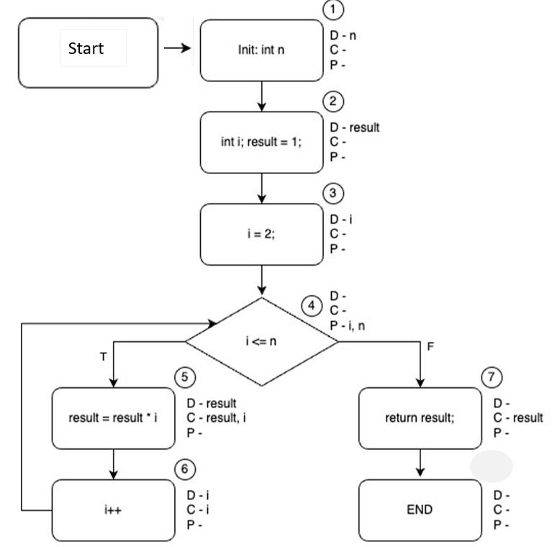

Variable | Def | C-use | P-use | Du-path | Complete Path
n | 1 |  | {4,5} | 1,2,3,4, 5 | Start, 1,2,3,4,5,6,4,7, end
n | 1 |  | {4,7} | 1,2,3,4,7 | Start, 1,2,3,4,7, end
result | 2 | 5 |  | 2,3,4,5 | Start,1, 2,3,4,5 ,6, 4, 7, end
result | 2 | 7 |  | 2,3,4,7 | Start,1,2,3,4,7 , end
Result | 5 | 5 |  | 5,6,4,5 | Start, 1,2, 3, 4, 5,6,4,5, 6, 4, 7, end
Result | 5 | 7 |  | 5,6,4,7 | Start, 1, 2, 3, 4, 5, 6, 4 , 7, end
i | 3 |  | {4,5} | 3,4,5 | Start, 1, 2, 3, 4, 5, 6, 4, 7 end
i | 3 |  | {4,7} | 3,4,7 | Start, 1, 2, 3, 4, 7, end
i | 3 | 5 |  | 3,4,5 | Start, 1, 2, 3, 4, 5, 6, 4, 7, end
i | 3 | 6 |  | 3,4,5,6 | Start, 1, 2, 3, 4, 5, 6, 4, 7, end
i | 6 |  | {4,5} | 6,4, 5 | Start, 1, 2, 3,4, 5, 6, 4,5,6,4, 7, end
i | 6 |  | {4,7} | 6,4, 7 | Start, 1, 2, 3,4, 5, 6, 4, 7, end
i | 6 | 5 |  | 6,4,5 | Start, 1, 2, 3,4, 5, 6, 4, 5,6,4, 7, end
I | 6 | 6 |  | 6,4,5,6 | Start,1,2,3,4,5, 6,4,5,6,4,7, end

For Ex1 of Question3, provide a corresponding test suite that will each achieve.
- All-defs coverage
- All-uses coverage
- All-du-path coverage

All-defs:
The entries into my DU-pairs table that are highlighted green meet the all-defs criteria. Each definition, to one use. N at 1 is represented, result at 2 is represented, result at 5 is represented, I at 3 is represented and I at 6 is represented. Keep in mind, these are only represented once, and that is what we want as it meets the definition.
Variable | Def | C-use | P-use | Du-path | Complete Path
n | 1 |  | {4,5} | 1,2,3,4, 5 | Start, 1,2,3,4,5,6,4,7, end
n | 1 |  | {4,7} | 1,2,3,4,7 | Start, 1,2,3,4,7, end
result | 2 | 5 |  | 2,3,4,5 | Start,1, 2,3,4,5 ,6, 4, 7, end
result | 2 | 7 |  | 2,3,4,7 | Start,1,2,3,4,7 , end
Result | 5 | 5 |  | 5,6,4,5 | Start, 1,2, 3, 4, 5,6,4,5, 6, 4, 7, end
Result | 5 | 7 |  | 5,6,4,7 | Start, 1, 2, 3, 4, 5, 6, 4 , 7, end
i | 3 |  | {4,5} | 3,4,5 | Start, 1, 2, 3, 4, 5, 6, 4, 7 end
i | 3 |  | {4,7} | 3,4,7 | Start, 1, 2, 3, 4, 7, end
i | 3 | 5 |  | 3,4,5 | Start, 1, 2, 3, 4, 5, 6, 4, 7, end
i | 3 | 6 |  | 3,4,5,6 | Start, 1, 2, 3, 4, 5, 6, 4, 7, end
i | 6 |  | {4,5} | 6,4, 5 | Start, 1, 2, 3,4, 5, 6, 4,5,6,4, 7, end
i | 6 |  | {4,7} | 6,4, 7 | Start, 1, 2, 3,4, 5, 6, 4, 7, end
i | 6 | 5 |  | 6,4,5 | Start, 1, 2, 3,4, 5, 6, 4, 5,6,4, 7, end
I | 6 | 6 |  | 6,4,5,6 | Start,1,2,3,4,5, 6,4,5,6,4,7, end

5 paths meet the criteria, so I need to figure out 5 test case, as in, the input to force the execution of the path, and the expected output. If you note my table, tc3 and tc4 turned out to be duplicate paths, therefore, we only have 3 actual test cases. In terms of your assignments, please always include the duplicate paths, so I can check for correctness of answer when meeting the criteria.
Test case name | Du-pair | Path | Input (int n) | Output (result)
Tc1 | (1,{4,7},n) | Start, 1,2,3,4,7, end | 0 | 1
Tc2 | (2,5,result) | Start,1, 2, 3, 4, 5 ,6, 4, 7, end | 1 | 1
Tc3 | (5,7,result) | Start, 1, 2, 3, 4, 5, 6, 4 , 7, end | Same as tc2 | Same as tc2
Tc4 | (3,{4,7},i) | Start, 1,2,3,4,7, end | Same as tc1 | Same as tc1
Tc5 | (6,6,i) | Start,1,2,3,4,5, 6,4,5,6,4,7, end | 2 | 2

All-uses:
The entries into my DU-pairs table that are highlighted green meet the all-uses criteria. Each definition, to each uses. This is easy to calculate, as if you look at your du-pairs table and sum the number of unique c and p uses, that will tell you how many paths you need.
Variable | Def | C-use | P-use | Du-path | Complete Path
n | 1 |  | {4,5} | 1,2,3,4, 5 | Start, 1,2,3,4,5,6,4,7, end
n | 1 |  | {4,7} | 1,2,3,4,7 | Start, 1,2,3,4,7, end
result | 2 | 5 |  | 2,3,4,5 | Start,1, 2,3,4,5 ,6, 4, 7, end
result | 2 | 7 |  | 2,3,4,7 | Start,1,2,3,4,7 , end
Result | 5 | 5 |  | 5,6,4,5 | Start, 1,2, 3, 4, 5,6,4,5, 6, 4, 7, end
Result | 5 | 7 |  | 5,6,4,7 | Start, 1, 2, 3, 4, 5, 6, 4 , 7, end
i | 3 |  | {4,5} | 3,4,5 | Start, 1, 2, 3, 4, 5, 6, 4, 7 end
i | 3 |  | {4,7} | 3,4,7 | Start, 1, 2, 3, 4, 7, end
i | 3 | 5 |  | 3,4,5 | Start, 1, 2, 3, 4, 5, 6, 4, 7, end
i | 3 | 6 |  | 3,4,5,6 | Start, 1, 2, 3, 4, 5, 6, 4, 7, end
i | 6 |  | {4,5} | 6,4, 5 | Start, 1, 2, 3,4, 5, 6, 4,5,6,4, 7, end
i | 6 |  | {4,7} | 6,4, 7 | Start, 1, 2, 3,4, 5, 6, 4, 7, end
i | 6 | 5 |  | 6,4,5 | Start, 1, 2, 3,4, 5, 6, 4, 5,6,4, 7, end
I | 6 | 6 |  | 6,4,5,6 | Start,1,2,3,4,5, 6,4,5,6,4,7, end

14 paths meet the criteria, so I need to figure out 14 test case, as in, the input to force the execution of the path, and the expected output. Many of these are duplicates (yellow highlights), and I haven’t worked out the actual test case. For such a simple section of code, in reality, this is a bit overkill. That said – the exercise of analysing your code helps check for variables that have not been initialised, that haven’t been used or used correctly, and when something is defined and defined again. At the end of the day, if something compiles, it doesn’t mean its good or it doesn’t what its supposed to do – with enough bashing…anything will compile.
Test case name | Du-pair | Path | Input (int n) |  | Output (result)
Tc1 | (n) | Start, 1,2,3,4,5,6,4,7, end
Tc2 | (n) | Start, 1,2,3,4,7, end
Tc3 | (result) | Start,1, 2,3,4,5 ,6, 4, 7, end
Tc4 | (result) | Start,1,2,3,4,7 , end
Tc5 | (result) | Start, 1, 2, 3, 4, 5,6,4,5, 6, 4, 7, end
Tc6 | (result) | Start, 1, 2, 3, 4, 5, 6, 4 , 7, end
Tc7 | (i) | Start, 1, 2, 3, 4, 5, 6, 4, 7 end
Tc8 | (i) | Start, 1, 2, 3, 4, 7, end
Tc9 | (i) | Start, 1, 2, 3, 4, 5, 6, 4, 7, end
Tc10 | (i) | Start, 1, 2, 3, 4, 5, 6, 4, 7, end
Tc11 | (i) | Start, 1, 2, 3,4, 5, 6, 4,5,6,4, 7, end
tc12 | (i) | Start, 1, 2, 3,4, 5, 6, 4, 7, end
Tc13 | (i) | Start, 1, 2, 3,4, 5, 6, 4, 5,6,4, 7, end
Tc14 | (i) | Start,1,2,3,4,5, 6,4,5,6,4,7, end

All-du-path coverage:
All du-paths are connected by a single du-path, therefore the al-du-path set will be the same as the all-uses set. If the code contains an if-statement, you will probably find some du-pairs that are joined by more than one du-path.
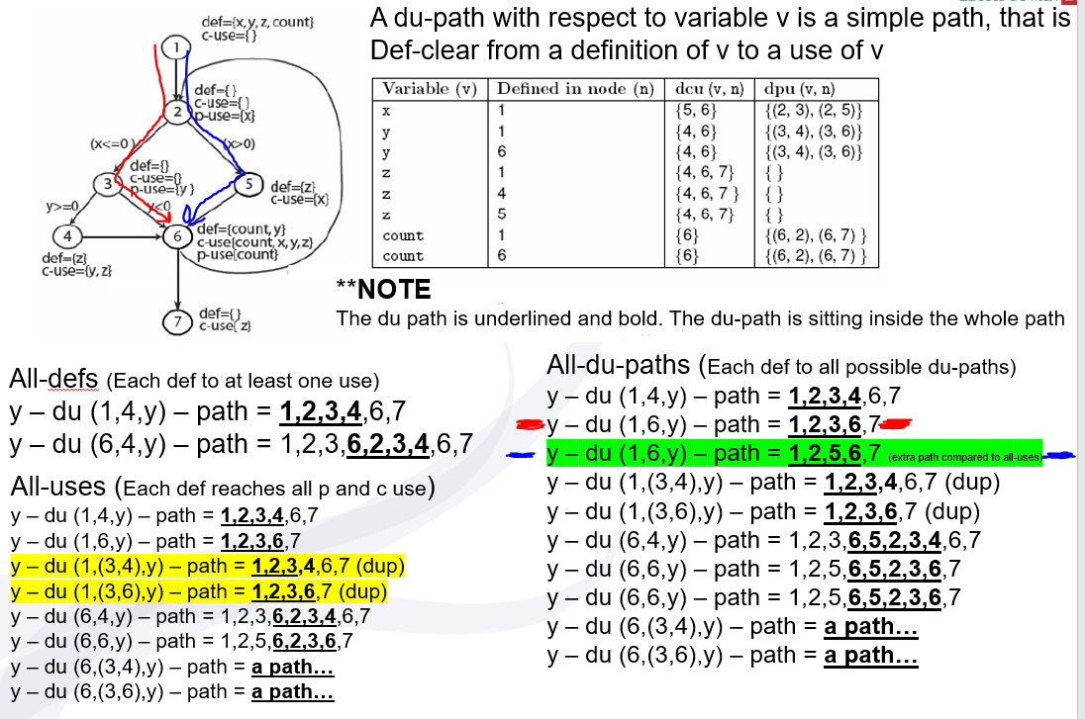
In this example, you can see how (1,6,y) has two associated du-paths, this doesn’t need to be reflected in the “all-uses’ set, BUT this must be accounted for in the “all-du-paths”set. Another example is (6,6,y), this du-pair can be connected by two du-paths; in the all-uses set, one path is needed, in the all-du-pairs set, both are needed.

